# 

# Endstream Rules

EndStream is a 2 player tactical trading card game about time-traveling outlaws seeking redemption.

Our universe is a stream of time. There are many streams, and the tech which allows streaming (moving within and between streams) has fallen into the wrong hands.

The characters of Endstream are broken and complicated. Each has committed a terrible deed. A Godlike AI has promised them redemption in exchange for a task: to destroy all of its Variants.

Like rocks in a stream, major events in history have the power to redirect the flow of time. Those events are called turnpoints, and their outcome can strengthen or weaken each player’s Operators. There are 3 types of outcomes, each advances a type of agenda: military, political, or scientific. In short: Want to make a soldier stronger? Undermine peace talks and start a war.

At your disposal are seven Operators and their AI Controller. Your goal is to either eliminate all rival operators or destroy the Controller. Each player has a stream of 6 random turnpoints, placed a century apart, thus creating a board of 6x2 upon which the operators can move.

## Set-Up

* The player must build a deck that contains a controller and 7 operators. Each operator has 2 tech cards slots (14 total). Each operator's tech card slot can hold a tech card from one of three categories: Weapons, Devices, or Relics. The deck is 22 cards total.
* On each player’s side of the board there is a stream of 6 turnpoints - areas on the board that represent a point in space and time in which a major event took place. Each turnpoint contains a random agenda card representing the major event, which provides the player with the means to use operators and abilities of the same type as the agenda. The cards are double sided and each side has a different agenda. The top-side agendas are the ones available to you [see board picture].
* At the beginning of the game the agenda cards are shuffled and dealt randomly into the turnpoints.
  + Before the game starts each player may choose to mulligan their agendas. If they do, then they remove all of their own agendas from the board, combine them with the unused ones, reshuffle them, and deal again. The cost for this is that they must begin the game with one of their agendas tapped. A player can choose to mulligan up to 6 times, each time paying by tapping an additional agenda. Each time they tap an agenda it must be the agenda furthest downstream, starting with 1800 and working up towards 2300.
* Each of the 6 turnpoints, when combined with the corresponding turnpoint of their opponent, represent a century in time.
* Operators start in the player’s hand, while controllers start on the board in their century. Each controller starts with a 100% vremenium charge, to activate tech cards. The charge is non-replenishable and when it is depleted, you can no longer charge tech cards.
* Flip a coin to decide which player goes first.
  + If a player goes first then none of their operators may travel into their opponent’s stream on their first turn. This includes both the operators using their MOVE as well as them being moved by some other ability or tech.
  + If a player goes first then they cannot push an agenda on their first turn.
  + If a player goes second then their first mulligan is free.
* During your turn, you can take the following actions in any order (there are no “phases”). How you take those actions and the limits on them will be explained below.
  + Activate operators (as long as you can pay the agenda cost) and charge a tech card
  + Use operators or controllers' abilities (as long as you can pay the agenda cost)
  + Move operators (each operator once per turn)
  + Spin agenda (once per turn, see below)

## Turn Actions

* **Activate operators** by playing them from your hand onto the board. Each operator belongs to a century (see operator picture) and they start in that century and in their own stream.
* To **activate an operator** or **use an ability** you must pay the agenda price activating agendas. To activate an agenda, simply move back the agenda cards with the agenda type you require [see board picture]. A gray agenda price  can be paid with any agenda and an agenda price with two halves such as  can be paid with either of the two corresponding agendas. Multi-types  must be paid with 1 military agenda and 2 scientific or political agendas.
  + All activated agendasare reset at the start of the player’s next turn.
  + You don’t have to use the agenda immediately after it has been activated. If you like you may activate a military agenda, then spin an agenda, then activate another military agendato pay for an ability that costs 2 military .
  + Once per turn you can **push an agenda**. If you do then that agenda card will give you two of that agenda type to spend rather than one. However, that agenda will be disabled on your next turn. You should move it two steps back on the board, and keep it there for the entirety of your following turn. Whilst an agenda is disabled you may not push it or any other agenda.
* **Activate a tech card** - use a tech card that the operator is armed with. To use a tech card you must pay the vremenium charge price from the controller. The card is removed from the game immediately, unless it is deployable or equippable. An operator can only use one tech card per turn, but may use abilities as normal.
* Each operator can move once during their player’s turn. They can **either** move up to 2 centuries upstream/downstream **or** they can move cross-stream (cross over to the same century in their opponent’s stream). The starting player cannot move their operators on their first turn. Controllers can move 1 step up/downstream and cannot move cross-stream.

* If an active operator finished their previous turn on any turnpoint, they can spin the agenda. This means that they flip the agenda card in their current turnpoint to the other side, giving them access to a different agenda type. Spinning an agenda causes a **ripple effect** - you must also flip all agendas upstream of the operator’s current turnpoint. Each player can do this once per turn at any time during their turn.
* All operators have the default ability: 2 Strike [1] to a controller.
* All actions in the player’s turn (abilities, movement, spinning agenda) can be done in any order, there are no phases.
  + You can spin an agenda before or after it was used.
  + You can use an ability, move, and then use the same ability again, as long as you can pay the agenda cost for it.
  + You can undo all of your previous actions, no action is final until you finish your **whole** turn. This means you can try any number of scenarios and see which one works best.

## Combat

* All abilities that do not specify otherwise:
  + **Can be used only on operators, controllers, and tech that are within the same turnpoint: same stream AND same century.**
  + **Are active for 1 turn, until the beginning of the player’s next turn.**
  + **Can be used as many times per turn as the player wants (providing they can pay the agenda cost).**
* Death is not always the end for stream travelers, especially when they have allies. To remove an operator from play you must disintegrate them - erase them from existence. To disintegrate an operator you must first disable them. To disable an operator you must lower their defenseto zero by using **strike [X]** (when **X** is the number of defense points lowered)or other abilities. Once an operator's defense is lowered to zero, they remain disabled for for the entirety of their owner’s next turn. At the beginning of the turn after that they are automatically **reactivated**. Mark disabled operators by rotating the card on its side [see board picture].
* An operator is disabled if other players have played enough strike or defense lowering abilities to equal or exceed the operator's defense in the same turn. *Example: Angela Storm has 3 defense. She receives Strike 1 from one enemy operator and Strike 2 from another. Angela Storm's defense is now at 0, so she is disabled. If any of those actions did not happen, nothing would have happened to Angela. There is no accumulated damage from only partially lowering defense in a previous turn.*
* Operators are disintegrated if their defense is once again lowered from their original value to zero while the operator is disabled. Unless specified otherwise, you cannot disable and disintegrate an operator in the same turn. You must disintegrate the operator while it is disabled and on the turn after it is disabled, or the operator becomes active again on their next turn. Disintegrated operators are removed from the board. *Example: On the opponent’s turn Angela is still disabled. Aran does Strike 3 to her, disintegrating Angela. If they did not, Angela would have become active again, on her player’s next turn.*
* *Example: Your opponent has Aran on the board and you have Ben Storm and Angela Storm.*
  + *Opponent’s turn 1: Aran uses his ability to Strike [3] on Ben Storm, reducing his defense to 0 and disabling him.*
  + *Your turn 1: Ben Storm remains disabled for this entire turn but you manage to use Angela Storm to Strike [2] on your opponent’s Aran, reducing his defense to 0 and disabling him.*
  + *Opponent’s turn 2: Aran remains disabled for this entire turn and your opponent is unable to reactivate him or attack either Ben Storm or Angela Storm.*
  + *Your turn 2: Ben Storm is automatically reactivated at the start of your turn. You use his ability to Strike [2] on the disabled Aran, reducing his defense to 0 once again, and disintegrating him. He is removed from the board.*
* When an operator is disintegrated, any tech that is attached to them is destroyed.
* Unlike operators, controllers have only armor which is lowered permanently with each strike, and once a controller's armor reaches 0 it is destroyed. Place damage counters on controllers to represent the Strike damage they have taken during the game. Controllers do not count as operators and cannot be influenced by abilities other than **Strike** (unless specified otherwise.) *Example: Mori did Strike 2 to SSV-93 URAL. Now SSV-93 URAL Has 8 armor for the rest of the game.*
* Deployed tech cards are destroyed by any strike ability (not defense lowering abilities) or any ability/tech card that has the effect of destroying tech cards
* The game is over when one player destroys their opponent’s controller, or when they disintegrate all of their opponent’s operators (including the ones in their hand).

## Operators

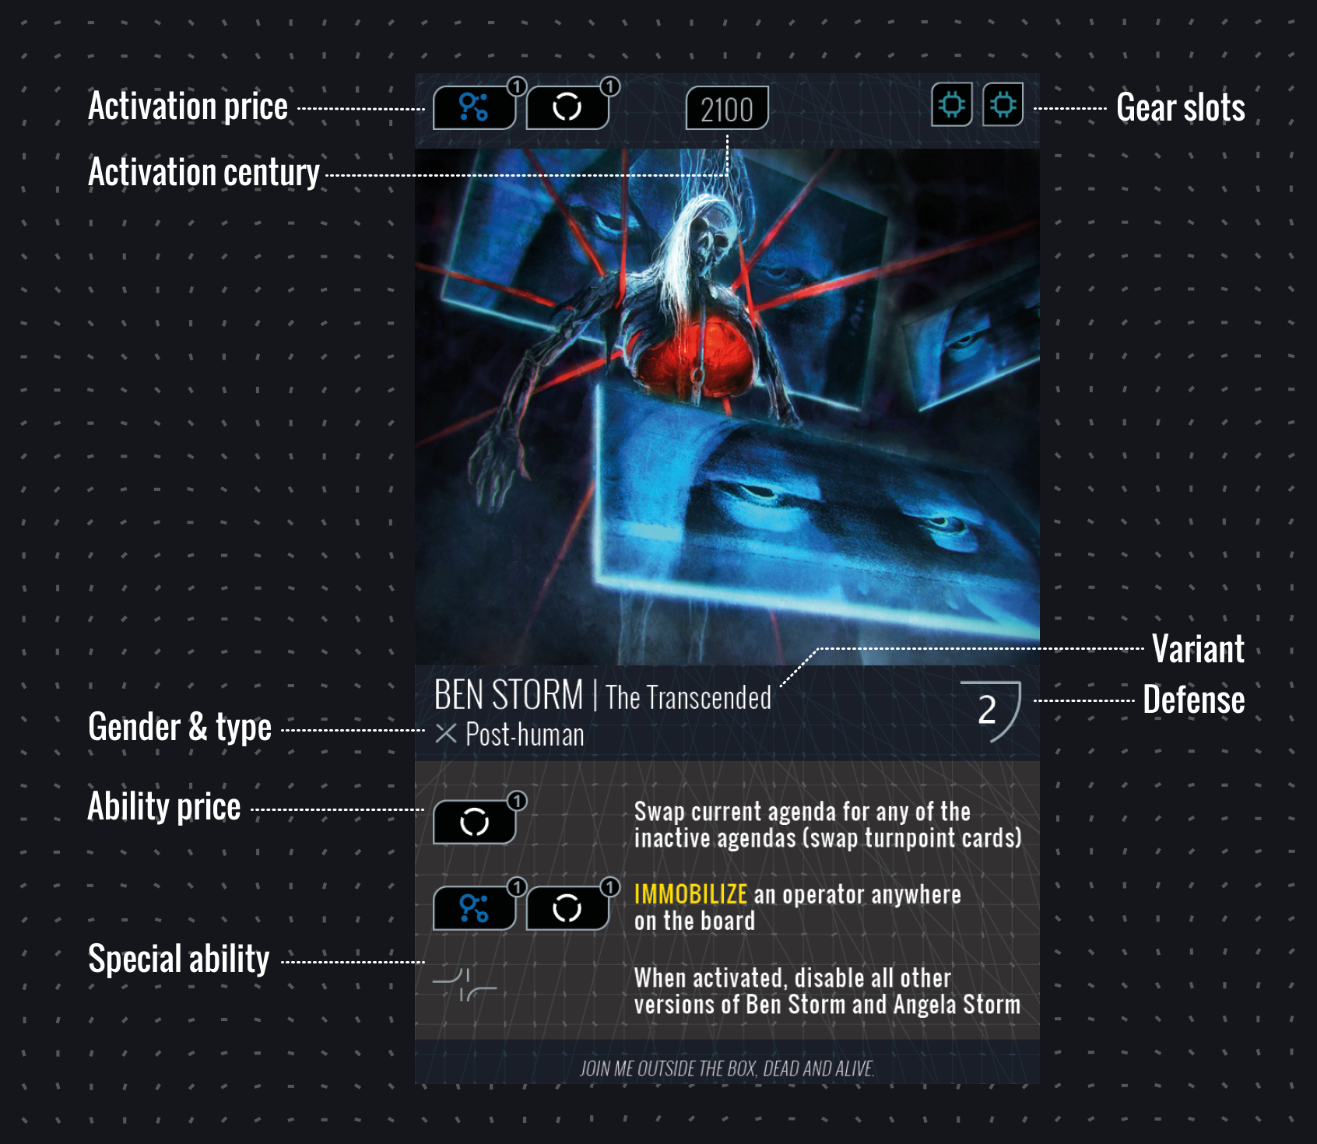

* **Variant** - some operators have different versions of themselves in different streams. Whilst they may have the same name, they are uniquely identified by their variant.
  + If an ability targets an operator by name then it can affect all variants of that operator. If an ability specifies the variant then it can only target that specific variant.
  + When building a deck you can have multiple cards with the same name but only one card with the same name and variant.

* **Move** - a general term for any kind of stream movement - time travel up to two centuries up or down a stream, or move to the *same* century in *another* stream.
  + **upstream** / **downstream** - Upward or downwards in the stream - going to the future or the past (respectively).
  + **Cross-stream** - move to the same century in another stream.

* **Defense** -the ability of operators to defend themselves, be it with body armor, a safe house provided by a friend, or political influence (not hit points or life).
* **Type** - some abilities work on specific operators, like Unit 707, drone, or post-human.
* **Special Ability** - some operators and all controllers have a special ability, one that is not activated by paying an agenda cost, but is instead always active.

## Tech

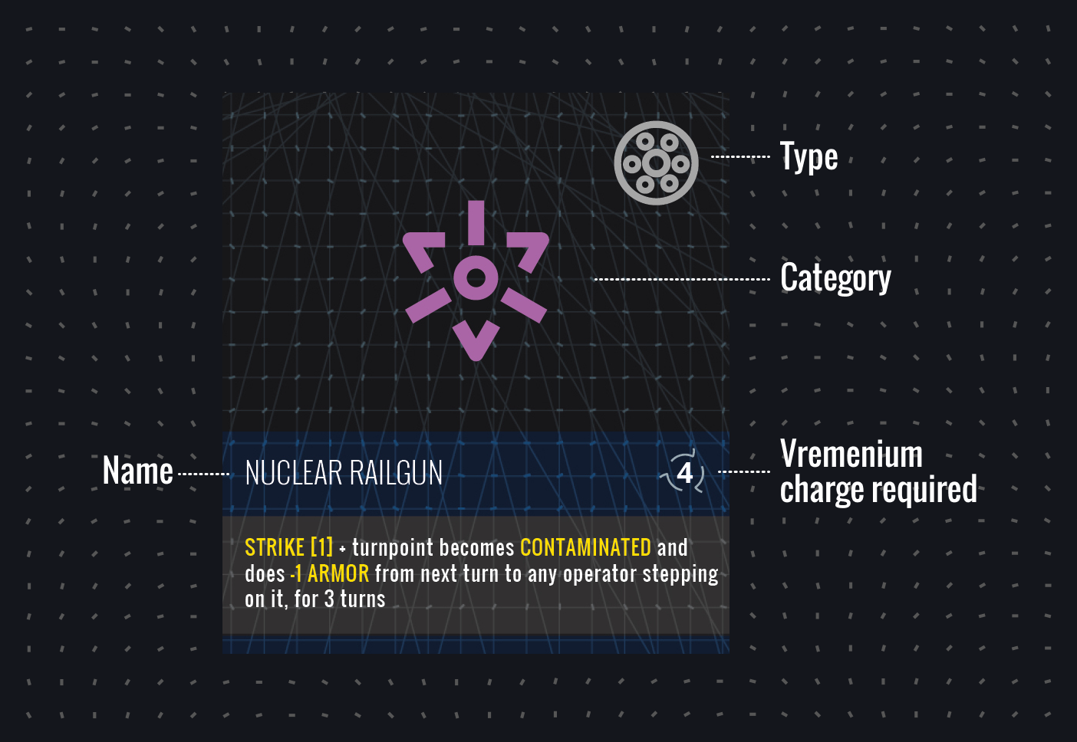

## Board

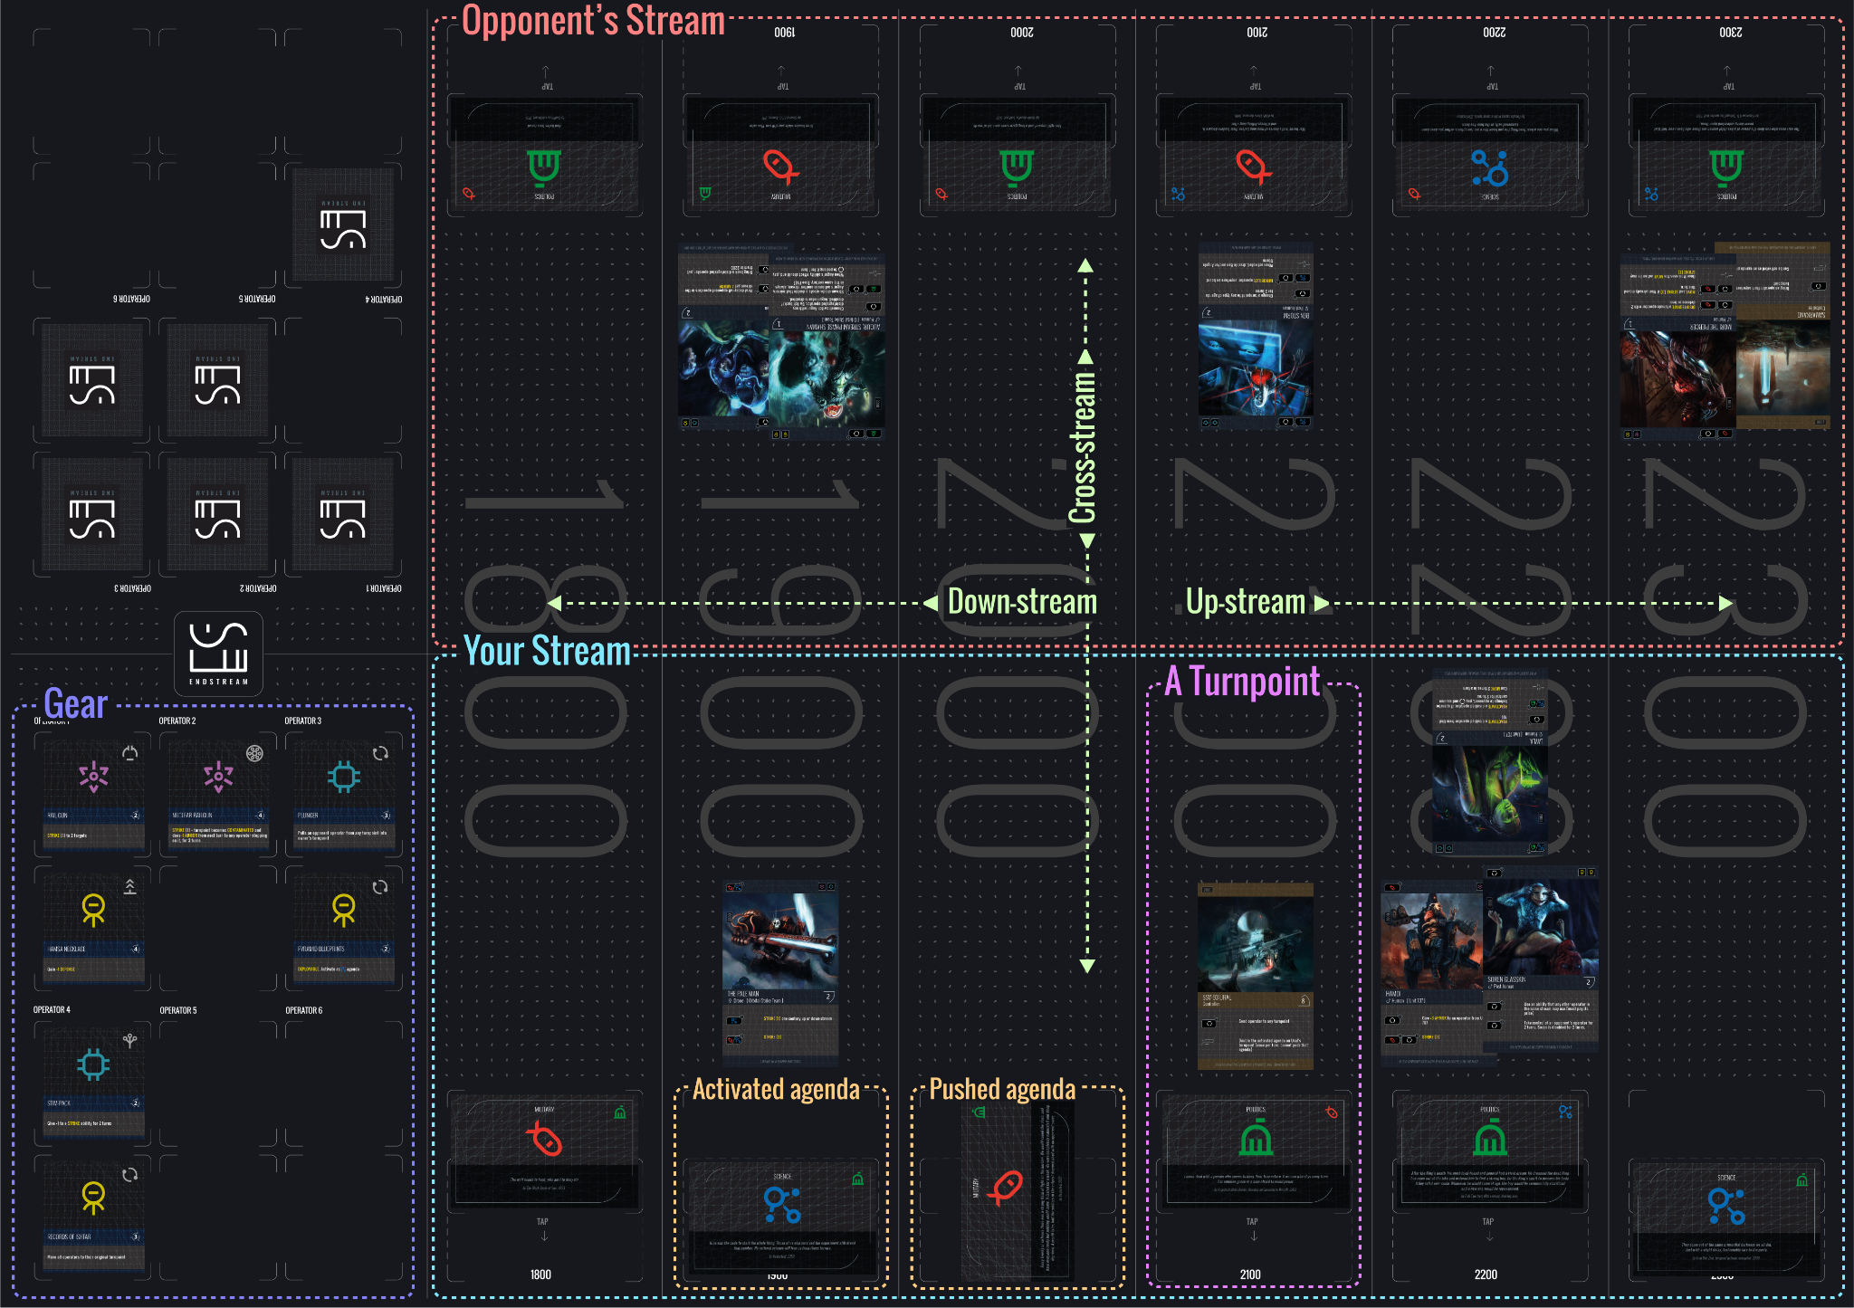

## Glossary

**Turnpoint** - an area of the board that represents one century in one stream. There are 12 turnpoints in total that represent 6 different centuries across 2 different streams. All operators and hideouts start in a specific turnpoint and travel between them. Each turnpoint has one agenda card.

**Stream** - the board is made up of 2 streams, one belonging to each player. A stream represents a player’s timeline and each contains 6 turnpoints representing the 6 centuries spanning from 1800 to 2300.

**Agenda** - a double-sided card representing a major event in a century[see board picture] Each side has a different agenda. Operators can spin agenda - intervene in those moments in history to create a different outcome. There are 3 types of **agendas**: **military**, **science**,and **politics**.

**Opera****tor** - the playable characters and anti-heroes of the game.

**C****ontrollers** - AI-gods who are worshiped by operators, and allow them to time travel.

**Tech** - single use devices with special abilities that can be carried by operators.

**Spin agenda** - flip the turnpoint card to the other side. Spinning an agenda causes a **ripple effect** - you must spin all agendas upstream.

## Keywords

**Target** - any operator, controller, or targetable tech.

**Enemy** - prefix to any operator, controller, tech, agenda or other entity that is controlled by your opponent.

**Friendly** - prefix to any operator, controller, tech, agenda or other entity that is controlled by you.

**Disabled** (operators) - disabled operators cannot move or use abilities. They can still be the target of abilities. Once an operator has been disabled they must spend the entirety of their next turn disabled.

**Disabled** (agendas) - disabled agendas cannot be activated or pushed. Unless otherwise stated the effect lasts for 1 turn.

### Operator Keywords

**STRIKE [x]** - reduce target’s defense or armor by x (armor must be reduced before defense).

**ARMOR** - operators can be given armor through the use of tech and abilities. If an operator with armor receives strike damage it depletes their armor before it affects their defense. Unlike defense, losing armor is permanent.

**IMMOBILIZED** - cannot move (but may still be moved by other operators or abilities).

**IMPAIRED** - cannot use any of their active abilities.

**UNTOUCHABLE** - cannot be the target of any ability or tech.

**CONTROL** - take control of an enemy operator. You may move the operator and use any of their abilities, but you cannot use their tech.

**FRAIL** - when defense is reduced to zero there is no disabled stage, the operator/tech is immediately disintegrated.

**STREAM -** an operator or tech travels to another turnpoint without using their MOVE.

### Tech Keywords

**EQUIP -** attach a tech card to a specified target. If no target is specified then the tech is attached to the operator who uses it. Equipped tech can be targeted by strike abilities, and are disintegrated upon receiving any strike damage. Unless otherwise specified an equipped tech is disintegrated once its effect has been applied once.

**DEPLOY -** deploy a tech card into a turnpoint. Its effect is active within that turnpoint. Deployed tech can be targeted by strike abilities, and are disintegrated upon receiving any strike damage.

### Turnpoint Keywords

**RESTRICT** - operators and tech are prevented from entering the turnpoint.

**LOCKDOWN** - operators and tech are prevented from entering or leaving the turnpoint.

**CONTAMINATE** - at the start of each player's turn operators in the turnpoint get -2 armor.

## FAQ

**Q:** Is there a correlation between an operator/controller’s location and the agendas you can use to pay?

**A:** No.

**Q:** Can an operator move after using an ability?

**A:** Yes. There are no “phases” during a turn, so you can take any action at any time and in any order you choose.

**Q:** Can I spin an agenda after activating it?

**A:** Yes. There are no “phases” during a turn, so you can take any action at any time and in any order you choose.

**Q:** Can both players use the same operators or controllers?

**A:** Yes, but be aware that if an ability targets an operator by name then, unless it is specified to only be **friendly** or **enemy** operators, it will be applied to all eligible instances of that operator. *Example: If you use Mia Star’s “Give +1 defense to all Orbital Strike operators on the board” ability, and your opponent has members of the Orbital Strike Team, their member will gain +1 defense too.*

**Q:** When an operator moves twice up/downstream, do they count as having moved into the one they passed through?   
**A:** No.

**Q:** Can Soren take the ability of a disabled operator?   
**A:** Yes.

## Starter Decks

| **CT: Samarkand** | **CT: SSV-93 Ural** | **CT: Jerushalem** |
| --- | --- | --- |
| **Angela Storm**  W: Stormpit  D: B.M.B.L. | **Mr. Roşu**  D: M.U.G.G.E.R. Droid  D: Stealth Suit | **The Pale Man**  W: 3Ax  D: Fake News Generator |
| **Ben Storm**  W: Nuclear Railgun  D: Spin Doctor AI | **Dr. Roşu**  W: Rail Gun  D: Neuro-Tuning Chip | **Mia Star**  D: SAT-P  D: Automated Damage Control |
| **Ben Storm The Looper**  W: Plasma Hammer  D: Temporal Tripwire | **Aran**  W: Vibroblade  W: Dirty Chrono-Bomb | **Augur, Stream-Phase Shaman**  R: Chrono-Accelerator  R: Mirror of Ishtar |
| **Soren Glasskin**  R: Smoke Water  R: Hand of Zaman | **Hamdi**  W: GML Facelock  D: EMP Bomb | **Man Bon-Hwa**  W: Temporal Rail Gun  D: Mars Rising |
| **Soren The Faceless**  D: Unstable Wormhole Generator  R: Zeitgeist Capsule | **Marwa**  W: The Ghost Sword of Saturn  D: Corrosive Nanobot Swarm | **Big Boy**  W: Nuclear Railgun  W: Dark Skies Protocol |
| **Akane**  D: Plunger  D: Temporal Reflector | **Layla**  D: Gene-adaptable perfume  R: Boneboil Staff | **Little Boy**  D: Neural Parasite  D: Stim-Pack |
| **Mori The Piercer**  W: Electrical Trident  R: Void-Frequency Hammer | **The Gray Baron**  D: Temporal Scrambler  R: War Shrine | **Ze’ev**  W: Plasma Mortar  R: Hamsa Necklace |